Term Website Planning Document

* Site Purpose:

The site purpose for this website is to let people know about this amazing place, where they can stay, rest, enjoy temples that are close by, give them information about weather, temples, history, family search, etc.

* Target Audience:

The target audience for this website is people that are interested on going to the temple, group of youth, people that want to get married there.

Persona 1: Josh Fink

Student

16 years old

Spends time doing family history and wants to do some names at the temple. He enjoys going for walks and learning more about family search.

Persona 2: Lucia Jensen

Grandmother

77 years old

She loves going to different temples, enjoys meeting new people and traveling alone. She is the only member of the family that is active in the church and loves doing the ordinances for the ones that are already in the other side of the veil. She is really good at family search and indexing.

* Site Map:

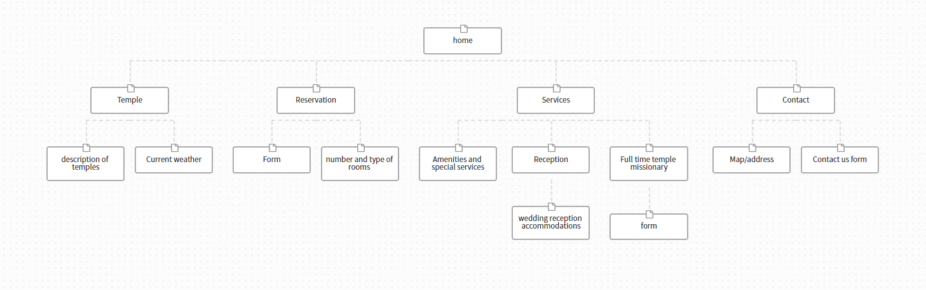

* Color Scheme:

Color Scheme


* Typography:

The typography that I am going to use is going to be the fonts:

Ubuntu and Hind Vadabora

* Wireframe Sketches:

Large Medium Small

